**PAAVAI COLLEGE OF TECHNOLOGY,NAMAKKAL**

**FERTILIZER RECOMMENDATION SYSTEM FOR DISEASE PREDICTION**

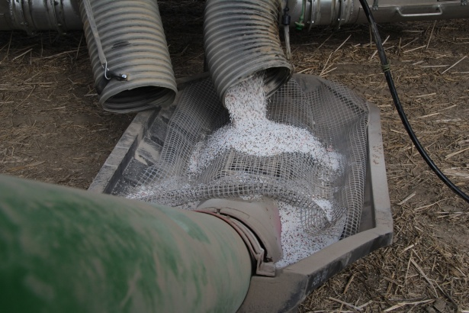

**PROJECT PROGRESS TRACKING**



| SPRINT | TOTAL STORY POINTS | DURATION | SPRINT START DATE | SPRINT END DATE(planned) | STORY POINTS COMPLETED | SPRINT RELEASE DATE |
| --- | --- | --- | --- | --- | --- | --- |
| Sprint-1 | 20 | 6 Days | 24 october 2022 | 29 Oct 2022 | 20 | 29 Oct 2022 |
| Sprint-2 | 20 | 6 Days | 31 october 2022 | 05 Nov 2022 | 20 | 05 Nov 2022 |
| Sprint-3 | 20 | 6 Days | 07 November 2022 | 12 Nov 2022 |  |  |
| Sprint-4 | 20 | 6 Days | 14 November 2022 | 19 Nov 2022 |  |  |

**VELOCITY:**

**Sprint 1 average velocity**

**Average velocity=20/2=10**

**Sprint 2 average velocity**

**Average velocity=20/2=10**

**Sprint 3 average velocity**

**Average velocity=20/1=20**

**Sprint 4 average velocity**

**Average velocity=20/2=10**

**BURNDOWN CHART**

